Save Our Forests

Date:
My address:

___________________________MP
House of Commons
London
SW1A 1AA

Dear ___________________________

I am writing to urge you to oppose the government’s proposals to sell off Forestry Commission forests in England. These proposals represent a great loss of amenity for the millions of British people who visit the national forest estate every week and wish to continue their enjoyment of it.

I believe that the proposals are ill-judged and poorly conceived, and represent nothing less than a massive asset stripping exercise.

The forests effectively belong to us, and the Forestry Commission exist to look after the forests in our interest. The current bill; Public Bodies Bill includes no detailed provisions that would prevent the forests being sold off and exploited at will.

Yours sincerely

Signed: __________________________
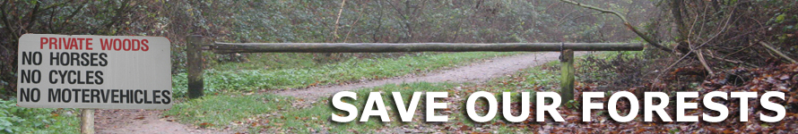
Date:

My address:

____________________________MP
House of Commons
London
SW1A 1AA

Dear __________________________

I object strongly to the government’s proposals to sell off Forestry Commission forests in England. These proposals represent a great loss of amenity for the millions of British people who visit the national forest estate every week and wish to continue their enjoyment of it.

The forests and woodlands in this country are wonderful ecosystems, both newly established and ancient, and provide society with a wider range of services than any other land use. A safe haven for biodiversity, a growing carbon store, flood regulation, a magnificent natural landscape, and a natural treasure for increasingly urbanised British people.

The financial value lies not in the forest, but in the land, particularly if you can get the trees off it. This is what the public recognises, and why more than 300,000 people have already signed an online petition http://www.38degrees.org.uk/save-our-forests opposing any sell off.

Yours sincerely

Signed: __________________________

